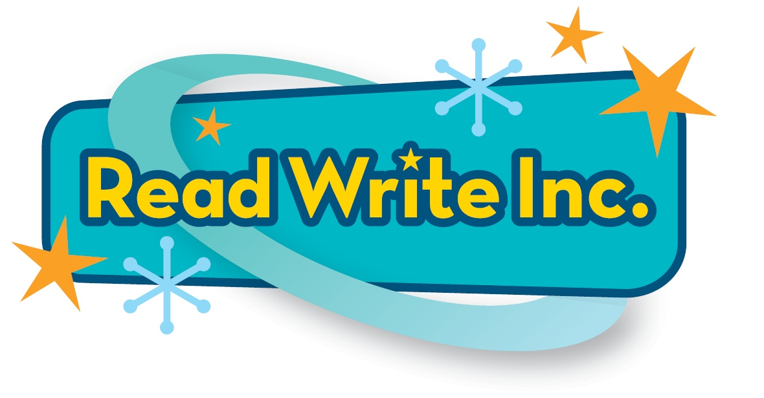
Read Write Inc. is closely matched to the Statutory Framework for the Early Years Foundation Stage (including Year R)
Training is vital to ensure your children get the best results using all the Read Write Inc. programmes. It is provided by Ruth Miskin Training, see www.ruthmiskintraining.com

Statutory Framework for the Early Years Foundation Stage (Including YR) | Read Write Inc. Phonics | Read Write Inc. Get Writing
Communication and language | These skills are embedded thoroughly: listening closely to the teacher, talking with and listening to a partner at every point in the lesson.
Listening and attention – ‘Children listen attentively in a range of situations. They listen to stories, anticipating key events and respond to what they hear with relevant comments, questions or actions. They give their attention to what others say and respond appropriately, while engaged in another activity.’ | In the Get Writing Handbook, there is detailed advice on how to how to plan, organise and run storytimes, ensuring that children develop an awareness of vocabulary and phrasing as well as engaging with the content of stories in terms of characters, settings and events.  Storytime sessions (explained in the Get Writing Handbook and on ruthmiskintraining.com) give children access to fiction, non-fiction and poetry at a level beyond that at which they can read independently.
Understanding – ‘Children follow instructions involving several ideas or actions. They answer ‘how’ and ‘why’ questions about their experiences and in response to stories or events.’ | In the Get Writing Handbook, questions are suggested to encourage children to talk about stories that they have heard or read, and to expand their vocabulary along with their ideas.
Speaking – ‘Children express themselves effectively, showing awareness of listeners’ needs. They use past, present and future forms accurately when talking about events that have happened or are to happen in the future. They develop their own narratives and explanations by connecting ideas or events.’ | In the Get Writing Handbook, there are suggestions for how ‘Talk through the day’ can encourage children to use new vocabulary, comment on events that are happening, and have happened, thereby developing their own narratives.
Literacy
Reading – ‘Children read and understand simple sentences. They use phonic knowledge to decode regular words and read them aloud accurately. They also read some common irregular words. They demonstrate understanding when talking with others about what they have read.’ | Phonic knowledge is taught in the Speed sounds lessons and applied in the storybook lessons. Children start reading simple sentences in the Red Ditty books and then read fiction and non-fiction books carefully matched to their growing phonic knowledge from Green level onwards.  They decode words using phonic knowledge but also learn Red words (common irregular words). Talking about the books is an integral part of the programme.  Storytime sessions (explained in the Get Writing Handbook and on ruthmiskintraining.com) give children access to fiction, non-fiction and poetry at at a level beyond which they can read independently. | Storytime sessions (explained in the Get Writing Handbook and on ruthmiskintraining.com) give children access to fiction, non-fiction and poetry at a level beyond that at which they can read independently.
Writing – ‘Children use their phonic knowledge to write words in ways which match their spoken sounds. They also write some irregular common words. They write simple sentences which can be read by themselves and others. Some words are spelt correctly and others are phonetically plausible.’ | The Read Write Inc. Speed sounds lessons follow a careful progression, with sounds being introduced sequentially in a structured and systematic way. The broad order follows three sets:  * Set 1 teaches the most common sound-letter correspondences:  m a s d t / i n p g o / c k u b / f e l h sh r / j v y w / th z ch qu x ng nk  * Set 2 Speed sounds teaches alternative vowel sounds: ay ee igh ow oo oo ar or air ir ou oy  * Set 3 Speed sounds is made up of alternative spellings of Set 2 sounds: ea oi e a-e i-e o-e u-e aw are ur er ow ai oa ew ire ear ure  The Speed sounds are taught using cards and are the key focus sounds that children learn. As they move up the levels, more unusual correspondences that they need to learn are pointed out to them as alternatives on the Complex Speed Sound chart, e.g. ph is not taught using a sound card but as an alternative to the more common spelling ‘f’.  These have a special focus throughout the programme, to ensure children learn to read and spell them with confidence. | Building from writing phrases in the Red Ditty books, children go on to develop the ability to write simple sentences, supported by the Get Writing practice books.  There are 9 Get Writing! activities for each of the Read Write Inc. Phonics books making spelling a fundamental part of Read Write Inc. Get Writing.  1. Play ‘Fred Rhythms’ to learn to spell the words – encoding.  2. Play ‘Fred Fingers’ to memorise the spelling – encoding.  3. Carry out a spelling check – encoding.  4. Take a spelling test – encoding.  5. Hold a sentence – encoding.  6. Build a sentence – language comprehension and encoding.  7. Edit for spelling and punctuation – language comprehension and encoding.


